Week 5

Q.1). Create a NumPy array and display its shape, size, and data type.
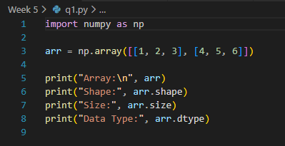
Output
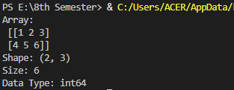

Q.2). Perform at least five basic arithmetic operations on NumPy arrays (addition of two arrays, subtraction, etc.).
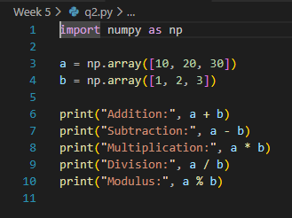
Output
Q.3). Create a NumPy array from having numbers between 1 to 100 and print only the prime numbers in them.
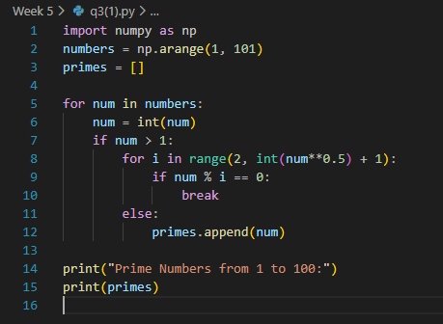
Output
Q.4). Take a NumPy array and demonstrate indexing and slicing on it.
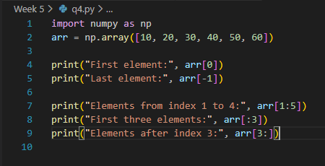
Output
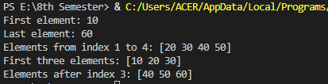

Q.5). Write the code to develop a Web page, as shown below, using frames:
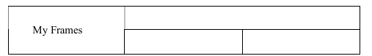
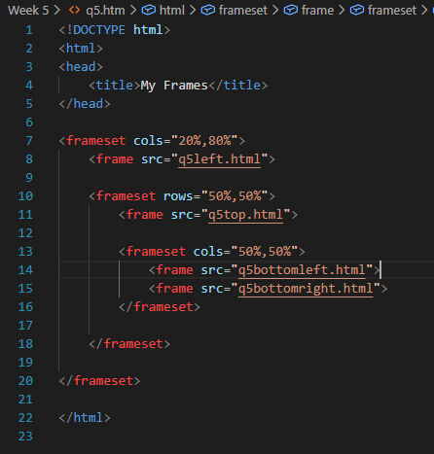
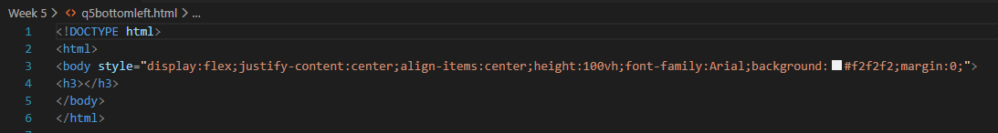
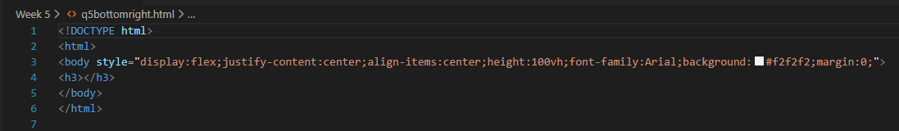
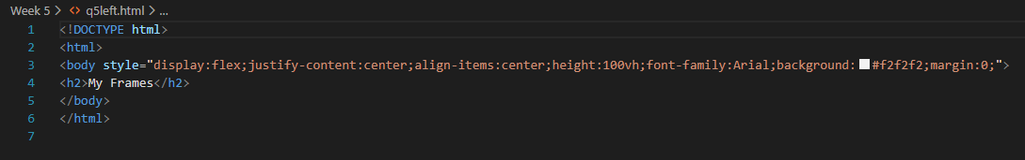
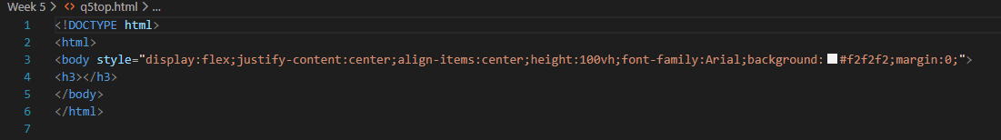
Output
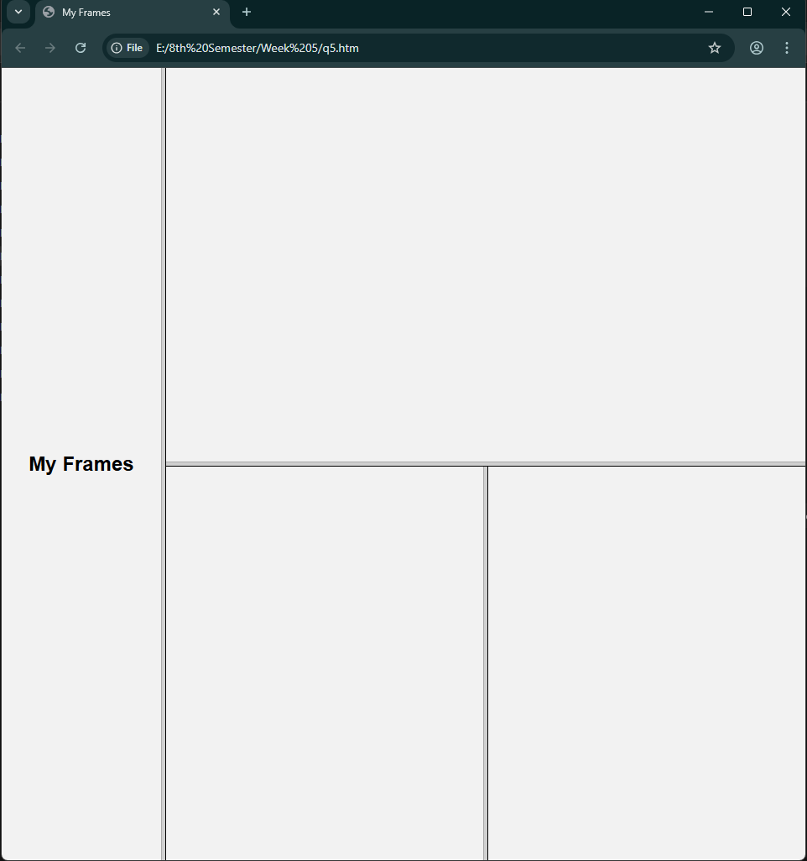

Q.6). Design a page with a text box called ‘name’ and a button with label ‘Enter.’ When you click on the button, another page should open, with the message “Welcome ”, where name should be equal to the name entered in the first page. Set default value of ‘name’ text box to Victoria. Add another button called Reset on click of this button name ‘text box’ should be set to 100 default values.
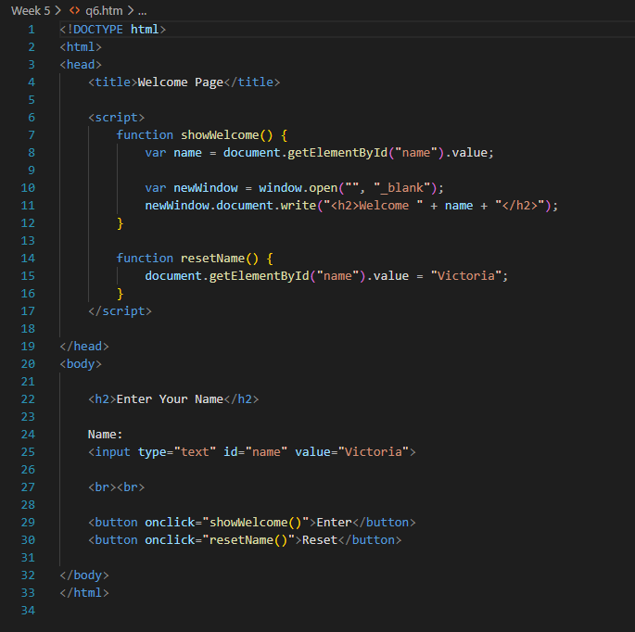
Output
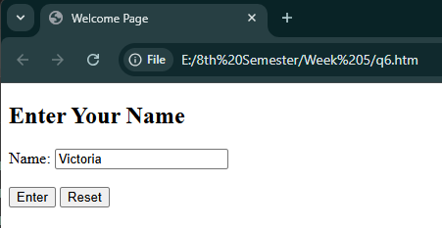
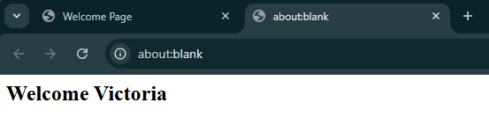

Q.7). Design a form in HTML using all input types.
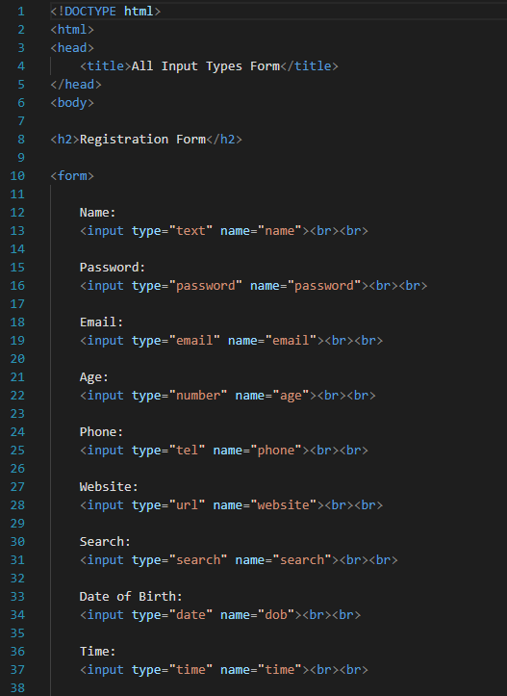
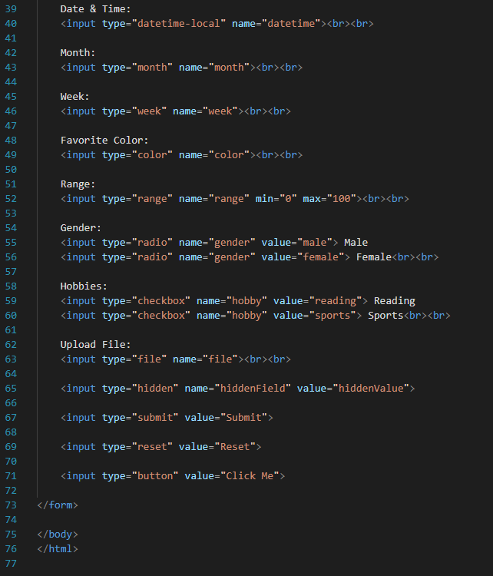
Output
